HUMAN BIOLOGY 12 Total __/40
EXTENDED RESPONSE 4 EVIDENCE OF EVOLUTION
Digging for dinosaur bones is a popular 'holiday' activity for adventurous visitors to outback Queensland. They're searching for large dinosaurs called sauropods.
These were land based dinosaurs and they roamed the vast forested floodplains that surrounded the inland sea that covered much of Queensland and central Australia about 95 million years ago.
Well-preserved bones and other fossilized remains of these dinosaurs have been found in the rocks underlying the Mitchell grass downs that now dominate the landscape around the town of Winton.
This includes the remains of the largest dinosaur yet found in Australia - an animal that has been nicknamed 'Elliot'. These bones were first discovered in 1999 by local grazier David Elliott, he noticed a bone fragment on the surface of the ground as he was mustering sheep.
Scott Hocknull from the Queensland Museum says "it wasn't just any old fragment of bone that you find on the surface - this was a piece of thigh bone that measured 50cm in diameter, so you're talking about an animal with a 50cm wide knee".
Mr Hocknull describes the dimensions of this dinosaur (it was) "an animal with a four metre high rump, maybe 16 metres long and 20 tonnes in weight". "it wasn't just any old fragment of bone that you find on the surface..."The Queensland Museum has led a number of 'digs' at the Elliot site near Winton, involving the Elliott family and volunteers
- Who am i? _______________________________________________________________________
______________________________________________________________________________ 1m
- Describe me______________________________________________________________________
_________________________________________________________________________________________________________________________________________________________________________________________________________________________________________________________________________________________________________________________________1m
- a) When did I live? __________________________________________________________________
______________________________________________________________________________1m
b) How did I die? ____________________________________________________________________
_________________________________________________________________________________________________________________________________________________________________________________________________________________________________________________________________________________________________________________________________2m
- How was I fossilized? _____________________________________________________________
_________________________________________________________________________________________________________________________________________________________________________________________________________________________________________________________________________________________________________________________________3m

- Describe the climate and vegetation at the time I was alive
__________________________________________________________________________________________________________________________________________________________________________________________________________________________________________________________________________________________________________________________________________________________________________________________________________________1m
- What events had to occur for me to be discovered?? ________________________________________________________________________________________________________________________________________________________________________________________________________________________________________________2m
- What can we learn from this discovery?
______________________________________________________________________________________________________________________________________________________________________________________________________________________________2m
- Relative dating gives _______________________________________________________________
_________________________________________________________________________________ 2m
- Absolute dating gives _______________________________________________________________
____________________________________________________________________________________ 2m
- What are the problems with relative dating? _________________________________________________________________________________________________________________________________________________________________________________________________________________________________________________________________________________________________________________________________ 4m
- What are the problems with Carbon dating? __________________________________________________________________________________________________________________________________________________________________________________________________________________________________________3m

- Describe with an example what an Index fossil is. _______________________________________________________________________________________________________________________________________________________________________________________________________________________________________________ 2m

- What is a half life? _______________________________________________________________________________________________________________________________________________________________________________________________________________________________________________ 2m
15. Examine the graph below, and then answer the following questions:
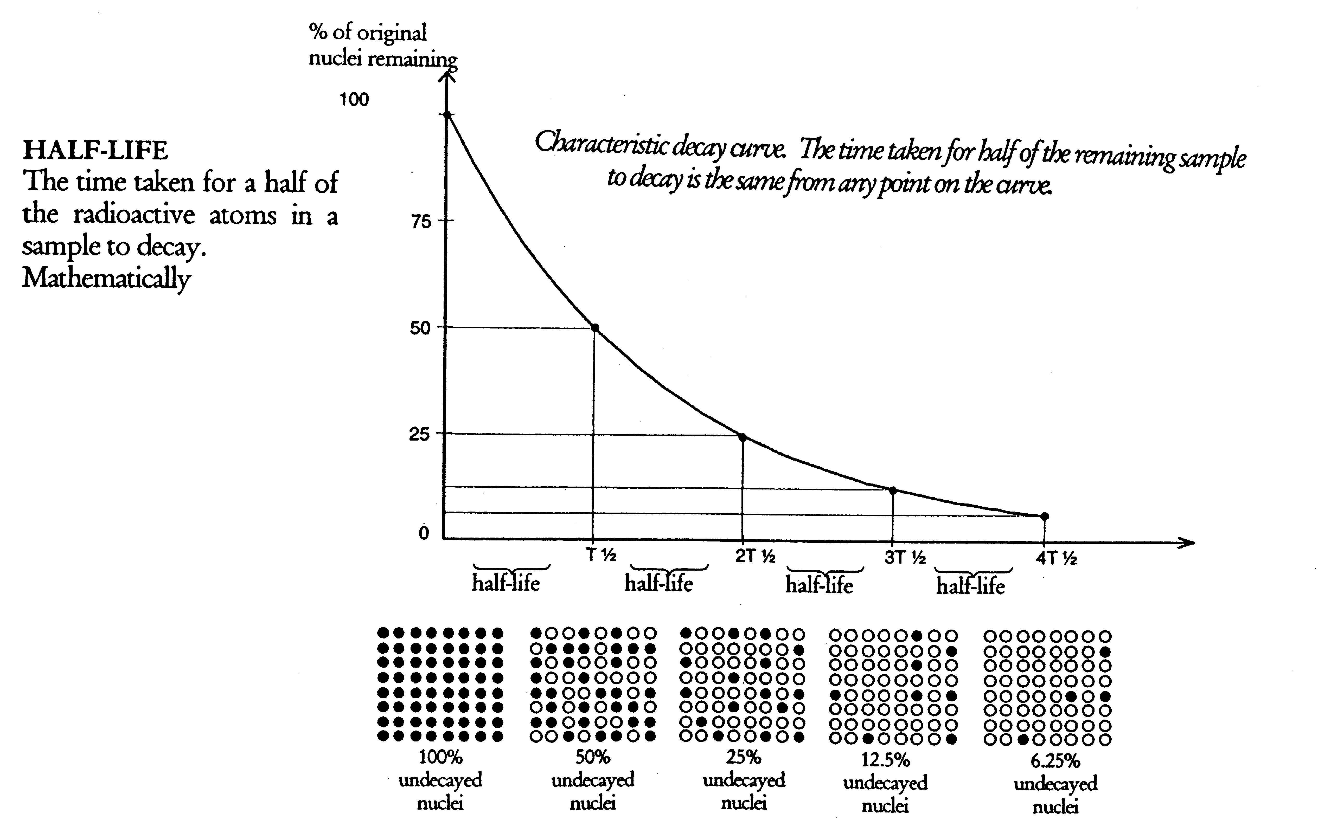
- How many half lives does it take to reduce the percentage of original nuclei to 25%? _____________ 1m
- If this represented a radioactive isotope with a half-life of 1300 million years, what is the age of a sample with 12.5% of the original nuclei left? ___________________________________________________ 1m
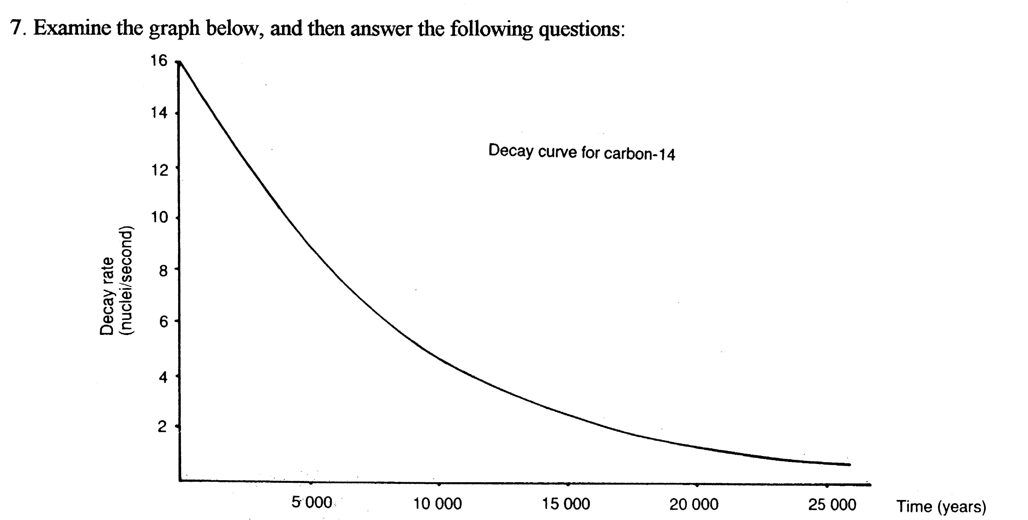
16. a) Calculate the age of a fossil that has a decay rate of 6 nuclei/second. ______________________________ 1m
b) Assuming the half-life of C-14 is 5730 years, approximately how many half lives have passed? __________ 1m
c) Which of the following could be dated by this method and why?
i) an Australopithecine skull? ii) a stone hand axe?
iii) a Cro-Magnon skull? iv) a bone found in a layer above one dated at 60 000 years?
v) a bone found in a layer below one dated at 100 000 years?
_______________________________________________________________________________________________________________________________________________________________________________________________________________________________________________________________________________________________________________________________________________________ 2m
17. Answer the following in each of the following cases:
site A site B site C

1 1 1
2 2 2

3 3 3

4 4 4
5 5 5

Which strata is the oldest of all sites? ____________________________________________________________________________________1m
Which strata is the youngest of all sites? ___________________________________________________1m
Which site gives the best representation of the oldest fossils and why? _____________________________________________________________________________________________________________________________________________________________________2m
Naming the strata, which fossil is present in all three sites? What can you infer from this?
_________________________________________________________________________________________________________________________________________________________________________________________________________________________________________________________________________________________________________________________________________________________2m

